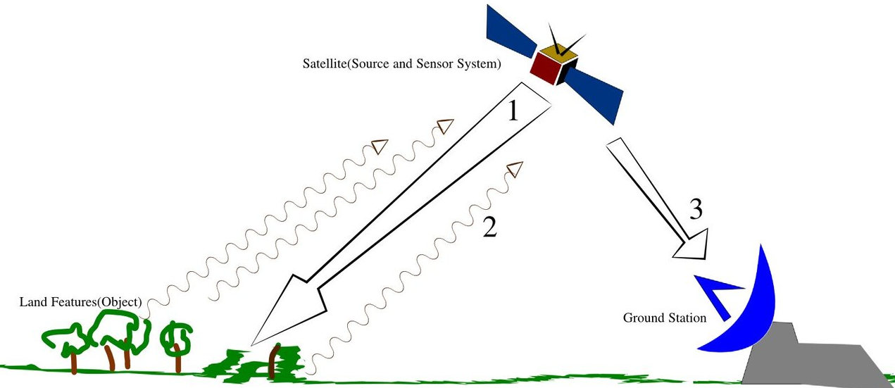

Land Object

Ground Station

Satellite (Source and Sensor System)